**Tech Saksham**



**Case Study Report**

**Data Analytics with Power Bi**

**“ Real – Time Analysis of Bank Customers ’’**

**“ Government Arts & Science College, Sivakasi ’’**

|  |  |
| --- | --- |
| **NM ID** | **NAME** |
| **7D67708F4BBABAABA424207B46D2299A** | **B.Karuppasamy** |

**Trainer Name :-** R.UMAMAHESWARI

**Master Trainer :-** R.UMAMAHESWARI

**ABSTRACT**

In the digital age, data has become an invaluable asset for businesses, particularly in the banking sector. The proposed project, "Real-Time Analysis of Bank Customers," aims to leverage Power BI, a leading business intelligence tool, to analyze and visualize real-time customer data. This project will enable banks to gain deep insights into customer behavior, preferences and trends, thereby facilitating data-driven decision- making and enhancing customer satisfaction. The real-time analysis will allow banks to respond promptly to changes in customer behavior or preferences, identify opportunities for cross-selling and up-selling, and tailor their products and services to meet customer needs. The project will also contribute to the broader goal of digital transformation in the banking sector, promoting efficiency, innovation and customer centricity.

**INDEX**

|  |  |  |
| --- | --- | --- |
| **Sr.No.** | **Table of Content** | **Page No.** |
| **1** | **Chapter 1**:- Introduction | **4** |
| **2** | **Chapter 2**:- Services And Tools Required | **6** |
| **3** | **Chapter 3**:- Project Architecture | **7** |
| **4** | **Chapter 4**:- Modelling and Result | **8** |
| **5** | Conclusion | **11** |
| **6** | Future Scope | **12** |

**CHAPTER 1**

**INTRODUCTION**

**1.1 Problem Statement :-**

**In today's competitive banking landscape, understanding customer behavior and preferences is crucial for customer retention and revenue generation. However, banks often face challenges in analyzing customer data due to the sheer volume and velocity of data generated. Traditional data analysis methods are time consuming and often fail to provide real-time insights. This lack of real-time analysis can lead to missed opportunities for customer engagement, cross-selling, and up-selling, impacting the bank's revenue generation and customer satisfaction. Furthermore, the complexity and diversity of customer data, which includes transaction history, customer feedback, and demographic data, pose additional challenges for data analysis.**

**1.2 Proposed Solution :-**

**The proposed solution is to develop a Power BI dashboard that can analyze and visualize real-time customer data. The dashboard will integrate data from various customer behavior or preferences, identify opportunities for cross-selling and up selling, and tailor their products and services to meet customer needs.**

**1.3 Features :-**

* **Real-Time Analysis :- The dashboard will provide real-time analysis of customer data.**
* **Customer Segmentation :- It will segment customers based on various parameters like age, income, transaction, behavior, etc.**
* **Trend Analysis :- The dashboard will identify and display trends in customer behavior.**
* **Predictive Analysis :- It will use historical data to predict future customer behavior.**

**1.4 Advantages :-**

* **Data-Driven Decisions :- Banks can make informed decisions based on real-time data analysis.**
* **Improved Customer Engagement :- Understanding customer behavior and trends can help banks engage with their customers more effectively.**
* **Increased Revenue :- By identifying opportunities for cross-selling and up-selling, banks can increase their revenue.**

**1.5 Scope :-**

**The scope of this project extends to all banking institutions that aim to leverage data for decision-making and customer engagement. The project can be further extended to incorporate more data sources and advanced analytics techniques, such as machine learning and artificial intelligence, to provide more sophisticated insights into customer behavior. The project also has the potential to be adapted for other sectors, such as retail, healthcare, and telecommunications, where understanding customer behavior is crucial. Furthermore, the project contributes to the broader goal of digital transformation in the banking sector, promoting efficiency, innovation, and customer- centricity.**

**CHAPTER 2**

**SERVICES AND TOOLS REQUIRED**

**2.1 Services Used : -**

* **Data Collection and Storage Services :- Banks need to collect and store customer data in real-time. This could be achieved through services like Azure Data Factory, Azure Event Hubs, or AWS Kinesis for real-time data collection, and Azure SQL Database or AWS RDS for data storage.**
* **Data Processing Services :- Services like Azure Stream Analytics or AWS Kinesis Data Analytics can be used to process the real-time data.**

**2.2 Tools and Software Requirements :-**

**Tools :-**

* **Power BI :- The main tool for this project is Power BI, which will be used to create interactive dashboards for real-time data visualization.**
* **Power Query :- This is a data connection technology that enables you to discover, connect, combine, and refine data across a wide variety of sources.**

**Software Requirements :-**

* **Power BI Desktop :- This is a Windows application that you can use to create reports and publish them to Power BI.**
* **Power BI Mobile :- This is a mobile application that you can use to access your reports and dashboards on the go.**

**CHAPTER 3**

**PROJECT ARCHITECTURE**

**ARCHITECTURE :-**

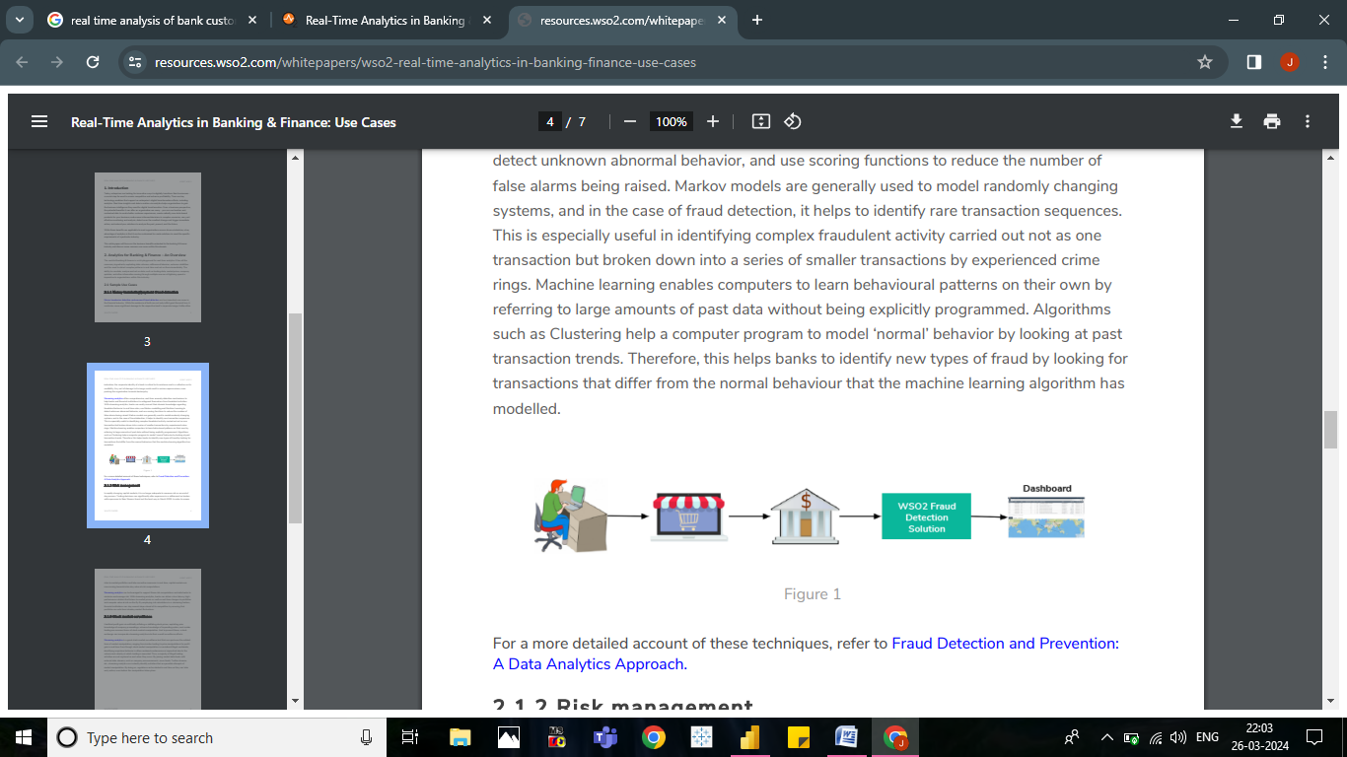

**CHAPTER 4**

**MODELING AND RESULT**

**Manage relationship :-**

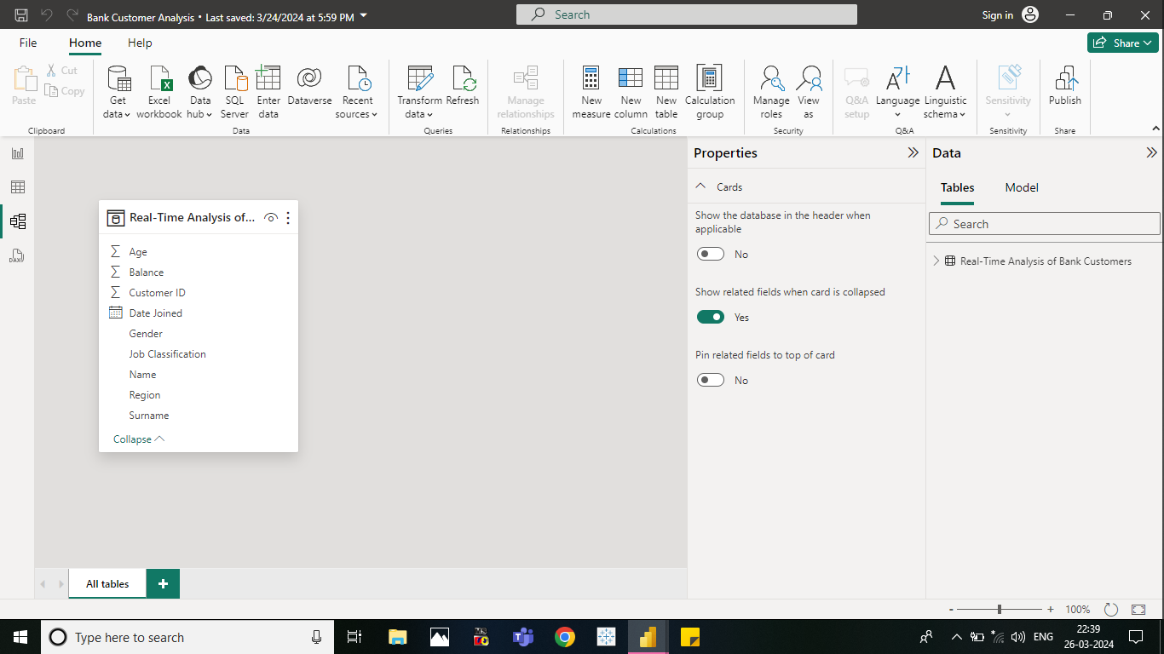

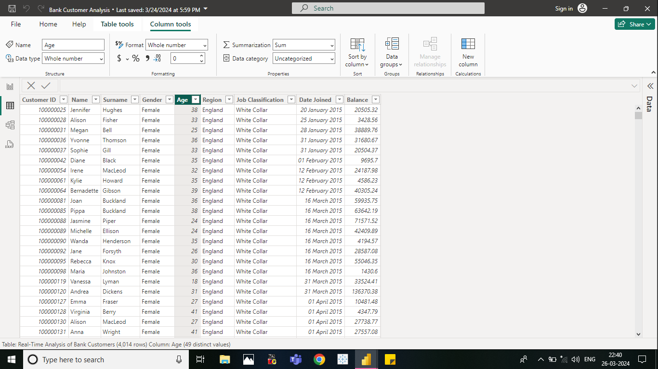

**Dashboard :-**

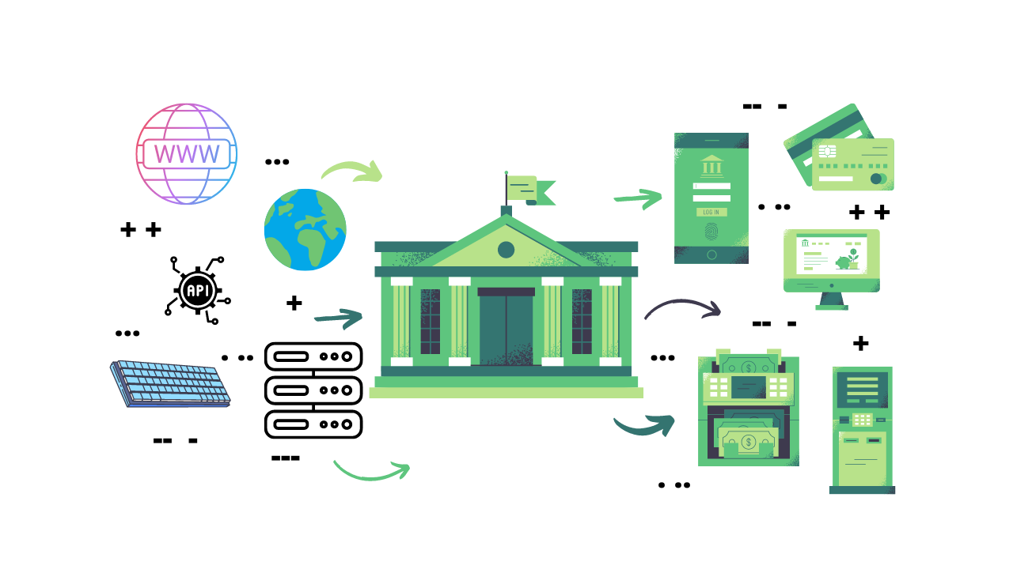

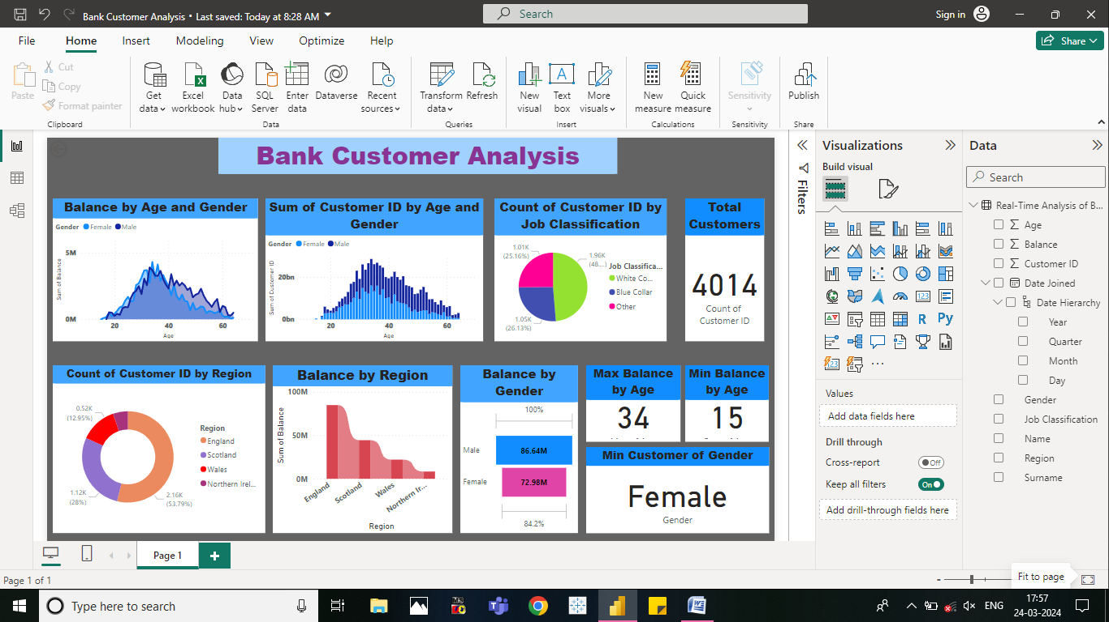

**CONCLUSION**

**The project "Real-Time Analysis of Bank Customers using Power BI has successfully demonstrated the potential of data analytics in the banking sector. The real-time I analysis of customer data has provided valuable insights into customer behavior, preferences, and trends, thereby facilitating informed decision-making. The interactive dashboards and reports have offered a comprehensive view of customer data, enabling the identification of patterns and correlations. This has not only improved the efficiency of data analysis but also enhanced the bank's ability to provide personalized services to its customers. The project has also highlighted the importance of data visualization in making complex data more understandable and accessible. The use of Power BI has made it possible to present data in a visually appealing and easy-to-understand format. thereby aiding in better decision-making.**

**FUTURE SCOPE**

**The future scope of this project is vast. With the advent of advanced analytics and machine learning, Power BI can be leveraged to predict future trends based on historical data. Integrating these predictive analytics into the project could enable the bank to anticipate customer needs and proactively offer solutions. Furthermore, Power BI's capability to integrate with various data sources opens up the possibility of incorporating more diverse datasets for a more holistic view of customers. As data privacy and security become increasingly important, future iterations of this project should focus on implementing robust data governance strategies. This would ensure the secure handling of sensitive customer data while complying with data protection regulations. Additionally, the project could explore the integration of real-time data streams to provide even more timely and relevant insights. This could potentially transform the way banks interact with their customers, leading to improved customer satisfaction and loyalty.**

**Reference**

<https://www.sas.com/en_us/webinars/real-time-analytics-in-banking.html>

<https://wso2.com/whitepapers/real-time-analytics-in-banking-and-finance-use-cases/>

LINKS